|  |  |
| --- | --- |
|  | **Bookstore Management System**  **Technical Design Document** |
| |  |  |  |  | | --- | --- | --- | --- | |  | **Prepared By / Last Updated By** | **Reviewed By** | **Approved By** | | **Name** | Hemadharshini S |  |  | | **Role** | Program Analyst Trainee |  |  | | **Signature** | Hemadharshini S |  |  | | **Date** |  |  |  | |
|  |

Table of Contents

1.0 Introduction 3

1.1 Purpose of this document 3

1.2 Project overview 3

2.0 Solution Summary 3

2.1 Scope 3

2.2 Risks 4

3.0 Use Case 4

4.0 System Design 8

4.1 Proposed design 8

5.0 Database Design 8

5.1 Data Model 8

5.2 Tables Structure 9

6.0 Appendices 9

6.1 Glossary 9

6.2 Other 9

7.0 Terms & Conditions 9

# Introduction

## 1.1 Purpose of this document

The bookstore management system serves as a crucial tool for efficiently organizing and overseeing various aspects of a bookstore. Its multifaceted purpose encompasses several key objectives. It improves overall corporate efficiency.

## Project overview

The BookStore management system is a website that allows admin to add, view, update, and delete book stocks. Book class has all the getters and setters for book stock name, drug price and author name.

The system is developed using Java as the programming language and MySQL as the database management system. The system uses Hibernate to connect to the database and execute queries.

The system has the feature of adding, updating, deleting, and viewing Book stock details in the database.

The system is designed to improve the efficiency and effectiveness of bookstore, as well as to enhance the user experience and satisfaction of the administrator. The system also aims to reduce manual errors, paper-work, and operational costs. The system is scalable, secure, and user-friendly.

# Solution Summary

## Scope

Following are the key features that needs to be implemented for the system:

1. Add Book Available
2. Update Book Details
3. View Book Details
4. Delete Book Available

## Risks

* **Technical Risks**: These include potential defects, system failures, and data corruption, among other hazards associated with software development. The process of integrating the new technology with the current systems may also come with dangers.
* **Integration Challenges**: Integrating of bookstore management system with existing systems (e.g., accounting, sales, and e-commerce platforms) can be very complex.
* **Security Vulnerabilities**: Unauthorized access, data breaches, or cyberattacks can compromise sensitive book stock information.
* **Performance Bottlenecks**: Slow database queries or inefficient indexing can impact overall system performance.
* **User Acceptance Risks**: There is a risk that end users may lack to accept or adapt to the new system.
* **Training Risks**: There could be risks associated with training staff to use the new system effectively.
* **Maintenance Risks**: Over time, the system will require updates and maintenance. There is a risk that these could be more costly or time-consuming than anticipated.

# Use Case

Who will be using this application:

* Admin

Admin – Responsible for managing the book stock products available in bookstore. Find book stock products available in the bookstore. There is an option to delete and update the items which were already added to my stocks.,

Find below the list of use case diagram that represents the list of Use Cases that needs to be incorporated.

Book Use Case

## Home Page

Header: Contains the website name and home menu.

Redirect Bar: Allows the admin to view all stocks that are added already and register new stocks.

Member Register Page: Allows the member to give name and their id .

Detail Section: Display a selection with description of the website.

 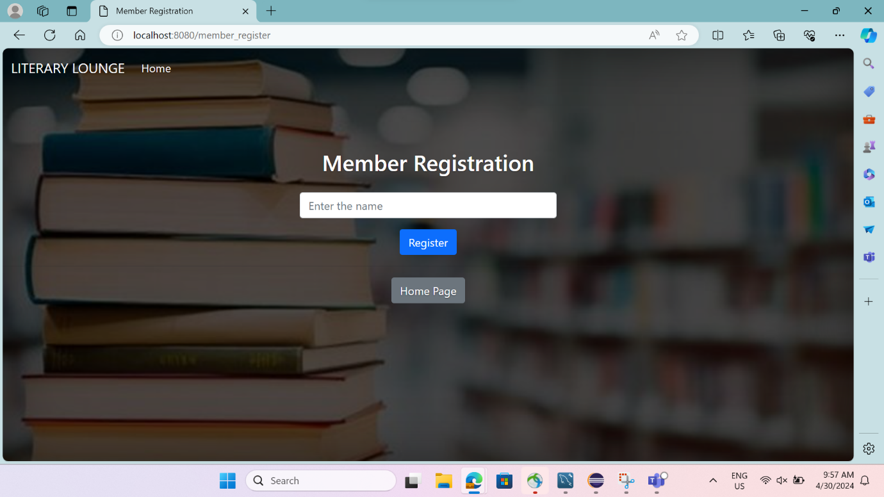

## Adding Book

**Save book:** Includes the book name, book price, availability, and author name.

**Sumbit Button:** Click the sumbit button the added book stocks will be updated in available books.

**Back to Home Button:** This button directs the admin to the home page.

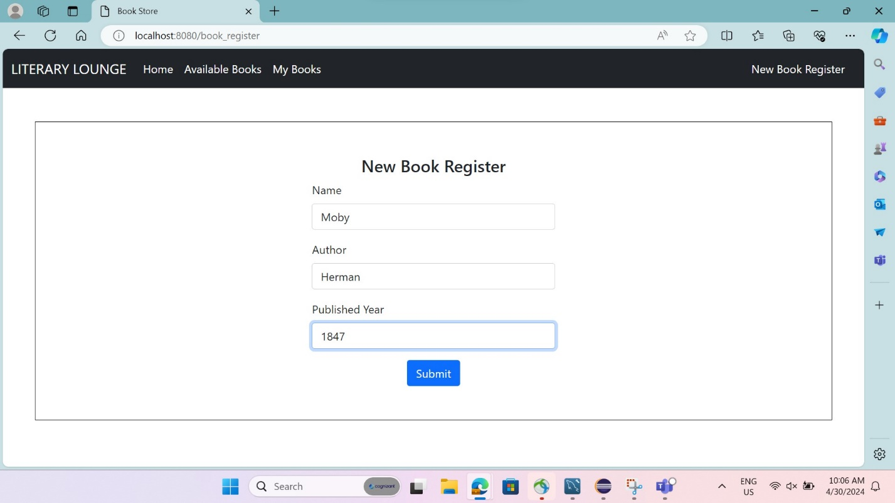

Admin can add the book stock products into the stock available in the platform. For Admin all the book stock products will be listed.

|  |  |
| --- | --- |
| Stock Name | Adding the book stocks |
| Actor(s) | Admin |
| Description | Add the book stock products available in the system |
| Pre-condition | Admin should have privilege to add book stock products List |
| Post-Condition | Stock products are listed in the screen. Each stock product will have option to edit and delete the book. |
| Basic Path | 1. Opens the book stock product list for admin in the browser. 2. Online book stock store system fetches the stock product list from the database. 3. List of menu items shown to the admin with following details about each menu item:    1. Book Name    2. Author Name    3. Year |

## 3.3 View Stocks

**Items Detail:** Admin can view the available books in my book page.

**Back to Home Button:** This button directs the admin to the home page.

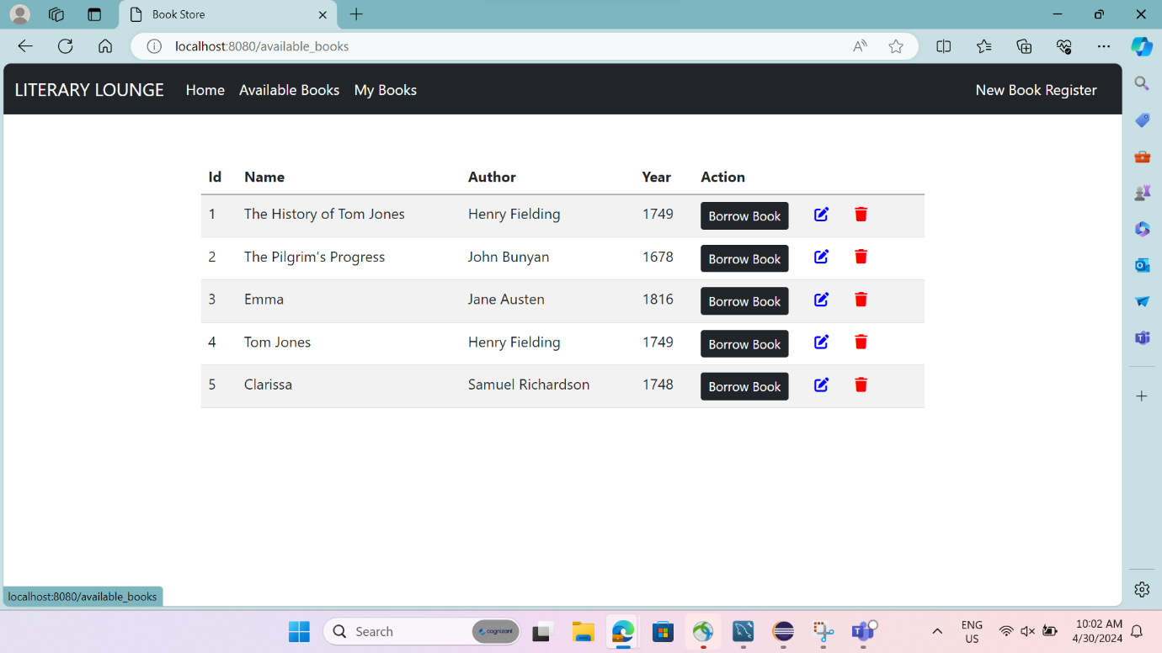

Admin uses this option to view the availability details of book products.

|  |  |
| --- | --- |
| Stock Name | View the book Stock Product |
| Actor(s) | Admin |
| Description | Admin is allowed to view the availability of the book stock product details |
| Pre-condition | Admin can view the book stock product privilege |
| Post-Condition | Availability book stock product details are saved in the database. |
| Basic Path | 1. Admin uses the view option on book stock products from book products List. 2. Fetched book stock product details from database and populate a form with following fields:    1. Book Name    2. Author Name    3. Year |
| Pre-condition | Admin should have added to my stocks |
| Post-Condition | A stock product is added to my stocks detail and added listed is viewed in my stocks. |
| Basic Path | 1. Admin uses this option to view the availability details of book stock products. |

## 3.4 Update Stocks

**Update Button:** This button helps the admin to update the items according to the availability.

Admin can update the list of book stock products in the Database.

|  |  |
| --- | --- |
| Stock Name | Update the Book Stock products |
| Actor(s) | Admin |
| Description | Admin can update the book stock products |
| Pre-condition | Admins have the privilege can change the name, author name, and year. |
| Post-Condition | Admin can update into a system of the changed book stock name. |
| Basic Path | 1. Admin uses the update option on book stock products from book List. 2. Fetched stock product details from database and populate a form with following fields:    1. Book Name    2. Author Name    3. Year |

## 3.5 Delete Stocks

**Delete Button:** This button helps the admin to delete the unavailable items from my books.

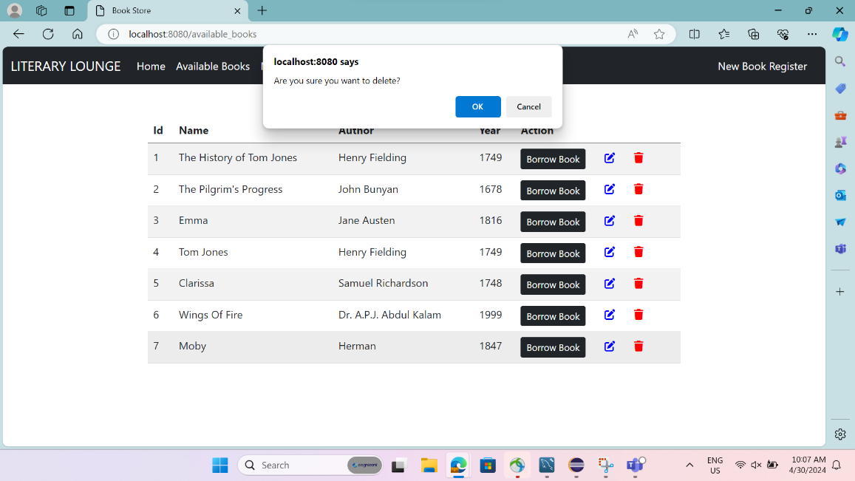

An admin can remove a stock product from my stocks.

|  |  |
| --- | --- |
| Stock Name | Remove book stock product from database |
| Actor(s) | Admin |
| Description | Admin can remove product which is not available in my book |
| Pre-condition | The admin can Remove stock privilege |
| Post-Condition | Unavailable stock products removed from the DB |
| Basic Path | 1. Admin can remove the unavailable stocks from my book. 2. Online book store removes the stock product from the book management database. |

## 3.6 My Stocks

**Items Detail:** Member can view the selected books in my book page.

**Back to Home Button:** This button directs the admin to the home page.

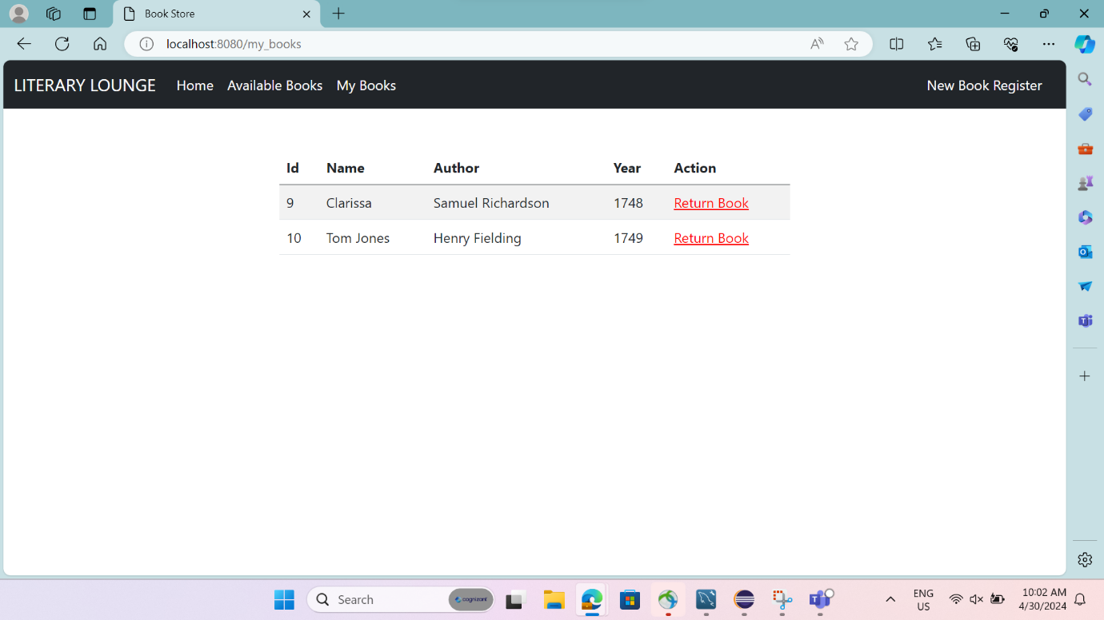

Admin uses this option to view the availability details of book products.

|  |  |
| --- | --- |
| Stock Name | View the book Stock Product |
| Actor(s) | Member |
| Description | Admin is allowed to view the availability of the book stock product details |
| Pre-condition | Admin can view the book stock product privilege |
| Post-Condition | Availability book stock product details are saved in the database. |
| Basic Path | 1. Admin uses the view option on book stock products from book products List. 2. Fetched book stock product details from database and populate a form with following fields:    1. Book Name    2. Author Name    3. Year |
| Pre-condition | Admin should have added to my stocks |
| Post-Condition | A stock product is added to my stocks detail and added listed is viewed in my stocks. |
| Basic Path | 1. Admin uses this option to view the availability details of book stock products. |

# System Design

## Proposed design

The suggested system aims to provide a system of improved facilities. The proposed system can overcome the overall constraints of the current system. The method ensures sufficient security and minimizes manual labor. This increases managerial efficiency, eliminates paperwork, reduces staff, and proves to be very cost effective in the long term.

# Database Design

## Data Model

The data model consists of columns for each attribute – Book Name, Author Name, and Price, each with fields relevant to that entity.

## Tables Structure

# Appendices

## Glossary

|  |  |
| --- | --- |
| **Acronyms** | **Definitions** |
| BMS | Bookstore Management System |

# Terms & Conditions

***Disclaimer: Please do not circulate or distribute this document outside of Cognizant Network, We have a Zero Tolerance Policy. Kindly adhere to 100% Compliance at all times.***